**Brandon Hobbs**

**DAD-220**

**March 7, 2022**

**Module 2 Lab Activity**

* Describe Employee and Branches  
    
  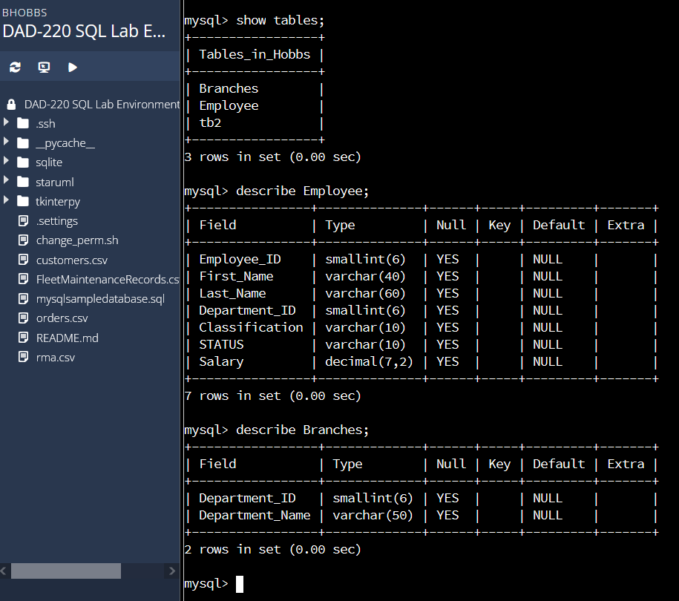
* Insert records into Employee  
  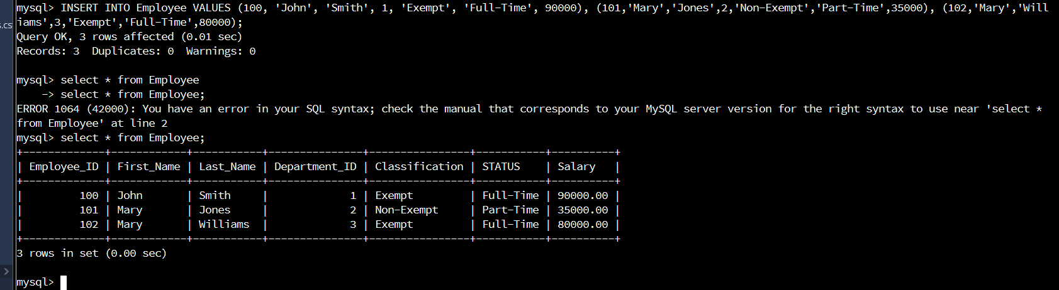
* Enter myself into the Employee table  
    
  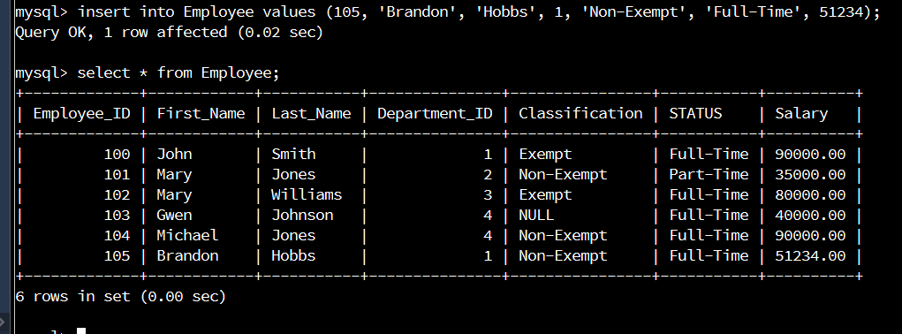
* Insert a famous musician  
  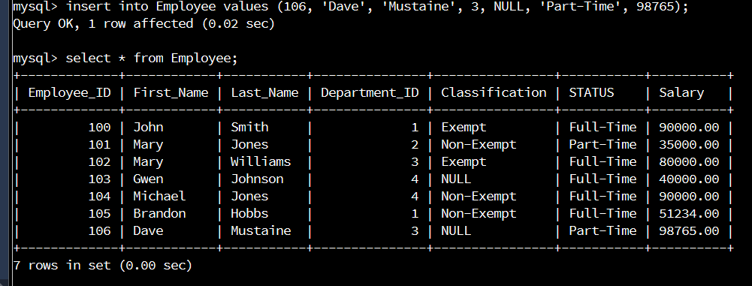
* Select the fields of last name, first name, employee id, and department id from the table  
  